**Practical No. 17: Develop program which implements the concept of overriding.**

1. **Practical Significance:**

Method overriding is used to change definition of method in subclass. Runtime Polymorphism is achieved through Method overriding. super keyword is used to call the parent class method or constructor.

1. **Relevant Course Outcome:**

Apply concept of inheritance for code reusability.

1. **Practical Outcome:**

Develop program which implements the concept of overriding.

1. **Minimum Theoretical Background:**

**Method of Overriding in Java**

Declaring a method in a subclass (child class) which is already existing in the parent class refers to method overriding in java.

The exact implementation in the subclass (child class) overrides (replaces) the implementation in the superclass by providing a method that has same name, same parameters or signature and same return type as that of method in the super(parent) class.

Inherited method

Overriden method

Parent Class

|  |
| --- |
| A |
| data 1  display()  calculate() |

extends

Overriding method

Sub Class

|  |
| --- |
| A |
| data s  display()  addition()  calculate() |

1. **Program Code:**

class Furniture

{

void color()

{

System.out.println("Furniture Color...");

}

}

class Chair extends Furniture

{

void color()

{

System.out.println("Chair Color...");

}

void heigth()

{

System.out.println("5ft..");

}

void work()

{

super.color();

heigth();

}

}

class SuperSub

{

public static void main(String[] args)

{

Chair obj = new Chair();

obj.work();

obj.color();

}

}

1. **Result:**

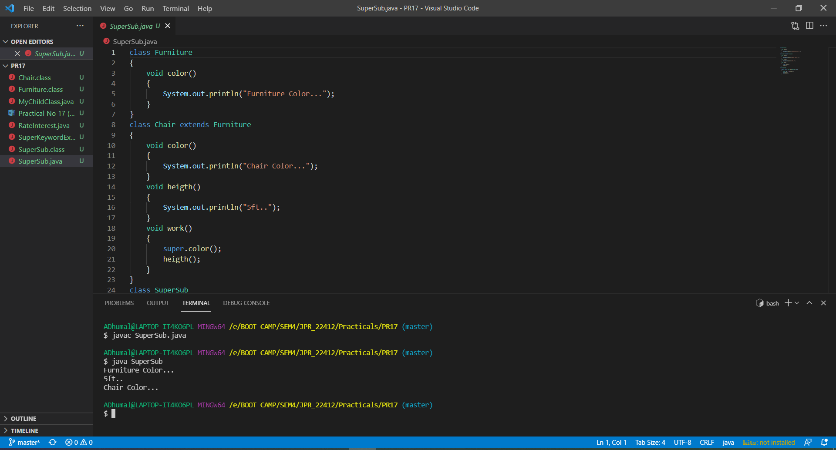

1. **Practical Related Questions:**
2. **State the difference between method overloading and method overriding.**

|  |  |  |
| --- | --- | --- |
| **No.** | **Method Overloading** | **Method Overriding** |
| 1 | Method overloading is used to increase the readability of the program. | Method overriding is used to provide the specific implementation of the method that is already provided by its super class. |
| 2 | Method overloading is performed within class. | Method overriding occurs in two classes that have is a (inheritance) relationship. |
| 3 | In method overloading, parameter must be different. | In method overriding, parameter must be same. |
| 4 | Method overloading is the example of compile time polymorphism. | Method overriding is the example of run time polymorphism. |
| 5 | Return type can be same or different in method overloading. But you must have to change the parameter. | Return type must be same or covariant in method |

1. **Method Overriding is an example of ………………………. (Compile Time Polymorphism/Run Time Polymorphism).**

Method Overriding is an example of Run Time Polymorphism.

1. **Write the rules of method overriding.**
2. Only inherited methods can be overridden.
3. The overriding method must have same argument list.
4. The overriding method must have same return type.
5. Private methods cannot be overridden.
6. Constructor cannot be overridden.
7. An abstract cannot be overridden.
8. If the parent class overridden method does throw an exception, then the child class overriding method can only throw the same, or subclass exception, or if may not throw any exception.
9. The overriding method must not have more restrictive access modifier.
10. User key word to invoke overridden method form child class.
11. Static methods and Final methods cannot be overridden.
12. **Write the use of super keyword in method overriding.**

The super keyword can also be used to invoke parent class method. It should be used of subclass contains the same method as parent class. In other words, it is used if method is overridden.

1. **Exercise:**
2. **Develop program to display the rate of interest of banks by method overriding method.**

class bank

{

int getroi()

{

return 0;

}

}

class SBI extends bank

{

int getroi()

{

return 8;

}

}

class ICICI extends bank

{

int getroi()

{

return 7;

}

}

class AXIS extends bank

{

int getroi()

{

return 9;

}

}

class RateInterest

{

public static void main(String args[])

{

SBI s = new SBI();

ICICI i = new ICICI();

AXIS a = new AXIS();

System.out.println("SBI rate of interest: "+s.getroi());

System.out.println("ICICI rate of interest: "+i.getroi());

System.out.println("AXIS rate of interest: "+a.getroi());

}

}

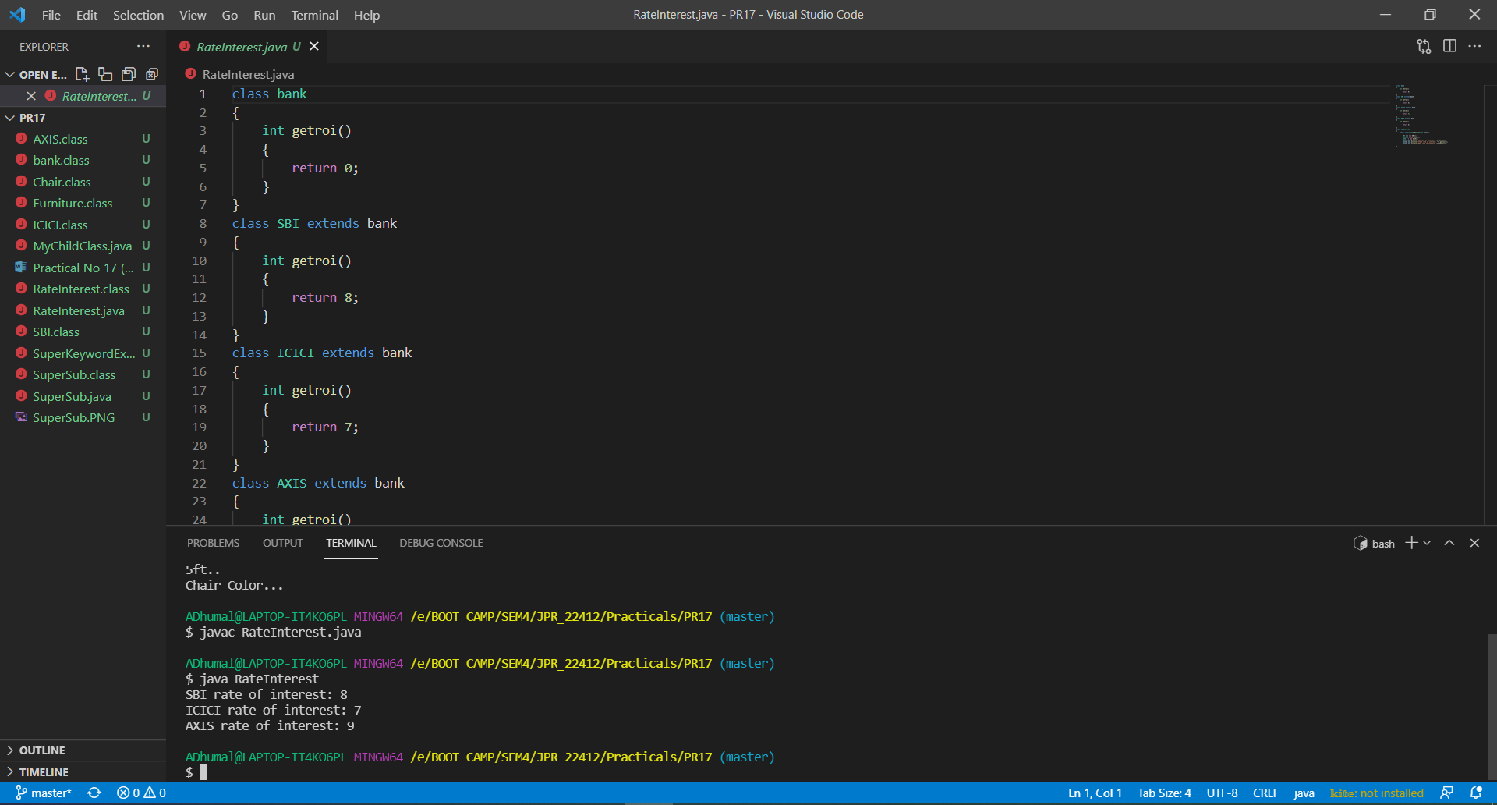

1. **Write the output of the following:**

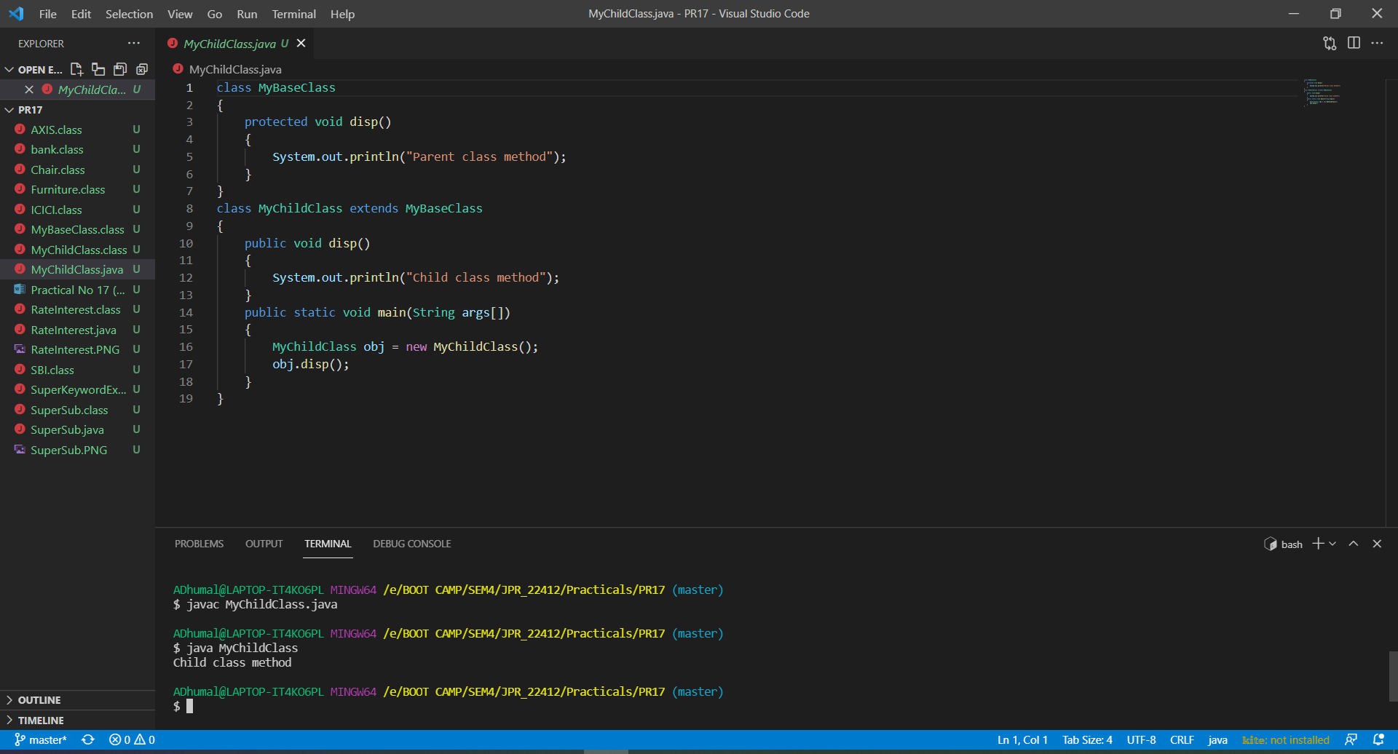

1. **Develop a program to extend ‘dog’ from ‘animal’ to override ‘move()’ method using super keyword.**

